Lab – Using Windows Calculator for Binary Conversions

1. Objectives

* Switch between two Windows Calculator modes.
* Use Windows Calculator to convert between decimal and binary.
* Use Windows Calculator to determine the number of hosts in a network with powers of 2.

1. Background / Scenario

When working with networking devices, a network technician should understand binary and decimal numbers. In this lab, you will use the Windows Calculator application to convert between these numbering systems. You will also use the “powers” function to determine the number of hosts that can be addressed based on the number of bits available.

1. Required Resources

* PC (Windows 10)
  + 1. Access Windows Calculator and determine mode of operation.
       1. Open the Windows Calculator application. Click **Start**, type **Calculator**. Select **Calculator** in the results.

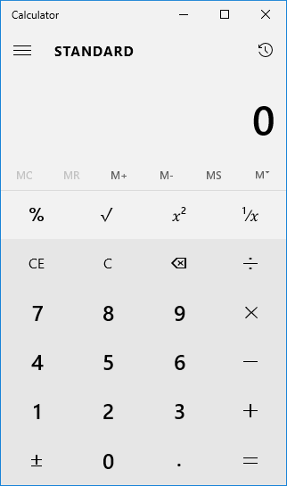

The Windows calculator supports different types of calculators. In the previous figure, the **Standard** mode is displayed. The standard mode calculator is useful for most basic tasks. If your calculator screen looks different, it may be because you opened in a different mode.

* + - 1. The Windows calculator provides other useful calculator modes. To switch between calculator modes, click the **Menu** icon (**≡**) located to the left of STANDARD in the application window.

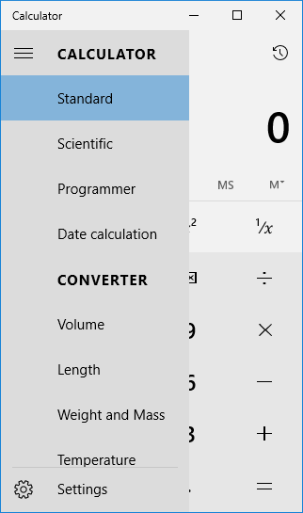

* + - 1. The calculator displays the other modes supported. Clicking a calculator option displays a customized calculator intended for a specific function.

Practice switching between calculator modes to see which options they provide.

* + 1. Convert between number systems.
       1. Select the **Programmer** mode calculator.

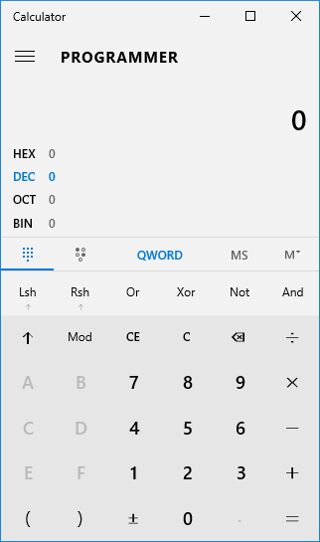

* + - 1. The Programmer calculator supports four numbering systems — HEX (Hexadecimal), DEC (Decimal), OCT (Octal), and BIN (Binary).

Which number system is currently active?

Which numbers on the number pad are active in Decimal mode?

* + - 1. Click **BIN**. Which numbers on the number pad are now active? ____________________________

Why do you think the other numbers are grayed out?

* + - 1. Click **DEC**. Using your mouse, click on the number **1** followed by the number **5** on the number pad. The decimal number 15 has now been entered.
      2. Now click on **BIN**. What happened to the number 15 listed in the textbox at the top of the window?

____________________________________________________________________________________

Enter the number 220 and select BIN.

What is the binary equivalent of 220?

* + - 1. Clear the binary value representing 220 in the window. From Binary mode, type in the following binary number: **11001100**. Select the **DEC**.

What is the decimal equivalent to the binary number of 11001100?

* + - 1. Convert the following decimal numbers to binary.

|  |  |
| --- | --- |
| Decimal | Binary |
| 86 |  |
| 175 |  |
| 204 |  |
| 19 |  |

* + - 1. Convert the following binary numbers to decimal.

|  |  |
| --- | --- |
| Binary | Binary |
| 1100 0011 |  |
| 0010 1010 |  |
| 0011 1000 |  |
| 1001 0011 |  |

* + 1. Convert host IP addresses.
       1. Computer hosts usually have two addresses, an Internet Protocol (IP) address and an Ethernet Media Access Control (MAC) address. For the benefit of humans, the IP address is normally represented as a dotted decimal notation, such as 192.168.10.2. Each of the decimal octets in the address or a mask can be converted to 8 binary bits. Remember that the computer only understands binary bits. If all 4 octets were converted to binary, how many bits would there be?
       2. IP addresses are normally shown with four decimal numbers ranging from 0 to 255 and separated by a period. Convert the 4 parts of the IP address 192.168.10.2 to binary.

|  |  |
| --- | --- |
| Decimal | Binary |
| 192 |  |
| 168 |  |
| 10 |  |
| 2 |  |

* + 1. Convert host IP subnet masks.
       1. Subnet masks, such as 255.255.255.0, are also represented as dotted decimal. A subnet mask will always consist of four 8-bit octets, each one represented as a decimal number. With the exception of decimal 0 (all 8 binary zeros) and decimal 255 (all 8 binary ones), each octet will have some number of ones on the left and some number of zeros on the right. Convert the 8 possible decimal subnet octet values to binary.

|  |  |
| --- | --- |
| Decimal | Binary |
| 0 |  |
| 128 |  |
| 192 |  |
| 224 |  |
| 240 |  |
| 248 |  |
| 252 |  |
| 254 |  |
| 255 |  |

* + - 1. Convert the four parts of the subnet mask 255.255.255.0 to binary.

|  |  |
| --- | --- |
| Decimal | Binary |
| 255 |  |
| 255 |  |
| 255 |  |
| 0 |  |

* + 1. Manipulate powers of 2 to determine the number of hosts on a network
       1. Binary numbers use two digits, 0 and 1. When you calculate how many hosts can be on a subnetwork, you use powers of two because binary is being used. As an example, we have a subnet mask that leaves six bits in the host portion of the IP address. In this case, the number of hosts on that network is 2 to the 6th power minus 2 (because you need a number to represent the network and a number that can be used to reach all the hosts—the broadcast address). The number 2 is always used because we are working in binary. The number 6 is the number of bits that are used for the host bits.
       2. Change the calculator view to **Scientific** mode. Input the number **2**. Select the **xy** key on the calculator, the key which raises a number to a power. Input the number **6**. To compete the operation, click on the =key, press **Enter** on the keyboard, or press the **=** key on the keyboard. The number 64 appears in the output. To subtract two, click on the minus (-) key and then the **2** key followed by the **=** key. The number 62 appears in the output. This means 62 hosts could be utilized.
       3. Using the previously described process, determine the number of hosts if the following number of bits are used for host bits.

|  |  |
| --- | --- |
| No. of Bits Used for Hosts | No. of Hosts |
| 5 |  |
| 14 |  |
| 24 |  |
| 10 |  |

* + - 1. Using a similar technique as learned previously, determine what 10 to the 4th power equals.

______________________________________________________________________________

* + - 1. Close the Windows Calculator application.

1. Reflection

List one other thing for which you might use the Windows Calculator scientific mode. It does not have to be related to networking.

_______________________________________________________________________________________

_______________________________________________________________________________________

_______________________________________________________________________________________